Vermont Natural Resources Conservation Districts

Guidance Handbook

Vermont Natural Resources Conservation Districts Guidance Handbook

Credits
This handbook was written in 2018 by Jeannie Bartlett (Franklin County NRCD), with assistance from Heather Robinson (Essex County NRCD), Marina Welch (White River NRCD), Eliza Rudegeair (Windham County NRCD), and Shelly Stiles (Bennington County NRCD), with final editing assistance from Susie Walsh Daloz, Jill Arace and Kerry O’Brien. This handbook was commissioned, funded, and published by the State Natural Resources Conservation Council (NRCC) with funding support from the USDA Natural Resources Conservation Service and the Vermont Agency of Agriculture, Food and Markets.

Purpose of the Handbook
This handbook is intended to provide an overview of Vermont’s Natural Resources Conservation Districts for new and existing Conservation District supervisors, managers and staff. It is intended primarily as an orientation and reference manual to help supervisors and staff successfully carry out their District’s mission. While the handbook is not a comprehensive training manual, it provides an essential overview of the programmatic and operational responsibilities of Conservation Districts.
Additional up-to-date training and detailed reference materials on a variety of topics are also available to District supervisors and staff.

Table of Contents
History of Conservation Districts 1
Purpose of Conservation Districts 2
Legal Powers and Duties of Vermont’s Conservation Districts 2
§ 723. Powers of Conservation Districts 2
Core Services of Conservation Districts 5
Vermont Conservation District Programs 6
Agricultural Assistance 7
Tactical Basin Planning 7
Municipal Stormwater Remediation 7
Natural Resource Conservation and Restoration 7
Conservation District Structure and Governance 8
Board of Supervisors 8
The Role of Supervisors 8
Developing Mission and Guiding Program Priorities 8
Working with District Staff 9
Providing Financial Oversight 10
Board Officers and Operations 10
Supervisor Recruitment 11
Supervisor Elections and Appointments 12
Orientation of New Supervisors 13
State Natural Resources Conservation Council 14
Vermont Association of Conservation Districts 16
Local Work Groups 18
National Conservation Partnership 18
National Association of Conservation Districts (NACD) 18
National Association of State Conservation Agencies (NASCA) 19
National Conservation District Employees Association (NCDEA) 19
National Association of Resource Conservation and Development Councils 19
National Conservation Planning Partnership 19
Partners 20
Acronyms 22

History of Conservation Districts
Conservation Districts were organized and created by federal law in 1937 in response to the devastating soil erosion conditions often referred to as the “Dust Bowl.” The federal Soil Erosion Service (SES) was created in 1933, later called the Soil Conservation Service (SCS) and is now the United States Department of Agriculture (USDA) Natural Resources Conservation Service (NRCS). Its purpose is to demonstrate the values of soil and water conservation by placing conservation measures on privately owned farms, ranches and forestlands in cooperation with landowners.

On February 27, 1937, President Franklin D. Roosevelt sent a letter to all state governors recommending the enactment of legislation enabling the creation of local soil conservation districts. The proposed act suggested that Conservation
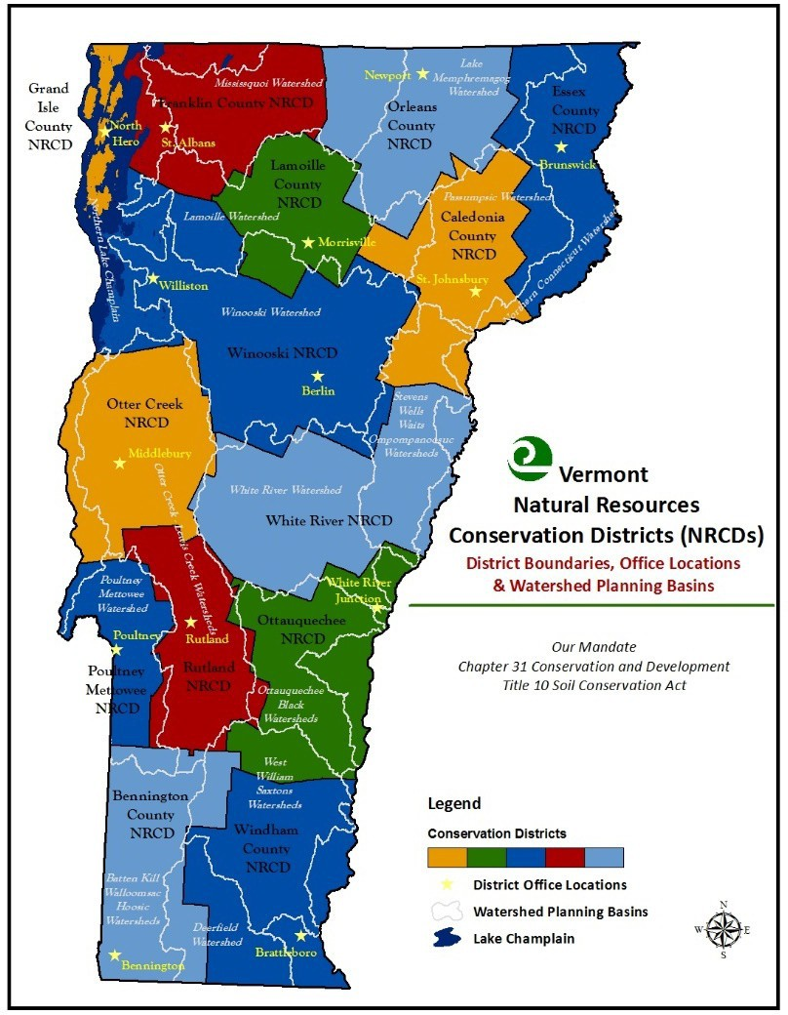

Districts be established to direct and manage soil erosion control programs. Each Conservation District would determine its own local needs and would have personal contact with individual landowners in the community, providing the local connections and expertise to inform their partner federal agency.

The first Soil Conservation District in the United States was organized on August 4, 1937 in North Carolina by Hugh Hammond Bennett, sometimes called the father of the conservation movement. In 1939, Vermont passed the Soil Conservation Act to enable the creation of Conservation Districts in Vermont. The first Conservation District in Vermont was established in 1940: the Poultney Mettowee Natural Resources Conservation District.
Today, a total of fourteen Conservation Districts cover Vermont with county or watershed boundaries. Vermont’s Soil

Map of Vermont's Conservation Districts

Conservation Act also created the State Natural Resources Conservation Council (NRCC, or “Council”) with responsibility for establishing, allocating funds to, assisting, and overseeing the Conservation Districts. Through NRCC, the governor and the legislature communicate their priorities to Conservation Districts, and Conservation Districts communicate their priorities to the state.

Purpose of Conservation Districts
The Vermont statute establishing Vermont’s Natural Resources Conservation Districts declares that the policy of the legislature [and thus the state] is “to provide for the conservation, development and use of the natural resources of this state and that the lands, water, forest and wildlife of the state of Vermont are among the basic assets of the state, and that the preservation of these lands, water, forests and wildlife by conservation, development and use is necessary to protect and promote the health, safety, and general welfare of its people” (10 V.S.A. Chapter 31 §701).

For much of their history, Conservation Districts served as local advisory committees to the USDA Natural Resources Conservation Service. This is now a relatively minor role of Vermont Conservation Districts that identify and execute local natural resource projects and programs consistent with local, state, regional and national priorities. In 2015, the Vermont Clean Water Act was passed, which brought the Conservation District’s body of work into greater focus. Conservation Districts have an integral role in Vermont’s Clean Water Initiative and play a key part in supporting landowners and municipalities adapting to new regulations and restoring water quality in Vermont. The role of each Vermont Conservation District varies depending on local natural resource concerns, but always includes assisting and encouraging the responsible use of the state’s natural resources. Conservation Districts are uniquely positioned to coordinate technical, financial, and educational resources to help meet the needs of local land users to conserve soil, water, and other natural resources.

Legal Powers and Duties of Vermont’s Conservation Districts
A Conservation District constitutes a subdivision of Vermont state government, and as a public body, has legal authorities. Vermont’s Soil Conservation Act (10 V.S.A. Chapter 31 § 723) gives supervisors and their staff the following powers (see statute for full text):

§ 723. Powers of Conservation Districts
- To conduct surveys, investigations and research relating to the character of soil erosion and its prevention and control measures and natural resources conservation;

- To conduct demonstration projects within the district on lands owned or controlled by this state or any of its agencies, with the cooperation of the agency administering and having jurisdiction, and on any other lands within the district upon obtaining the consent of the owners of the lands or the necessary rights or interests in the lands in order to demonstrate by example the means, methodsand

measures by which soil erosion, in all its forms, can be prevented and controlled and the conservation of natural resources;

- To carry out measures for the prevention and control of soil and stream bank erosion and the protection and conservation of natural resources within the district including, but not limited to, engineering operations, methods of cultivation, the growing of vegetation, and the changes in use of land, on lands owned or controlled by this state or any of its agencies, with the cooperation of the agency administering and having jurisdiction, and on any other lands within the district upon obtaining the consent of the owner of the lands;

- To cooperate, or enter into agreements with, and, within the limits of appropriations duly made available, to furnish financial or other aid to any agency, governmental or otherwise, or any owner of lands within the district, in the carrying on of erosion-control and prevention operations and conservation of natural resources within the district, subject to such conditions as the supervisors may deem necessary to advance the purposes of this chapter;

- To obtain options upon and to acquire by purchase, exchange, lease, gift, grant or bequest, any property, real or personal; to maintain, administer and improve any properties acquired; to receive income from the properties and to expend the income in carrying out the purposes and provisions of this chapter; and to borrow money, mortgage, sell, lease or otherwise dispose of any of its property or interests in property in furtherance of the purposes and the provisions of this chapter, provided however, that real estate shall not be mortgaged, and provided however, that the sale, lease or other disposition of real property of the district is approved by the written consent of the governor;

- To make available, on such terms as it shall prescribe, to landowners within the district, agricultural and engineering machinery and equipment, fertilizer, seeds and seedlings, and such other material or equipment as will assist the land owners to carry out operations upon their lands for the conservation of soil resources, control of soil and stream bank erosion and protection and conservation of natural resources;

- To construct, improve and maintain such structures as may be necessary or convenient forthe performance of any of the operations authorized in this chapter;

- To develop comprehensive plans for the conservation of soil resources and for the control and prevention of soil erosion and the protection and conservation of natural resources within thedistrict, which plans shall specify in such detail as may be possible, the acts, procedures, performances and avoidances which are necessary or desirable, and to publish such plans and information andbring

them to the attention of occupiers of lands within the district;

- To administer by purchase, grant or lease any soil conservation, erosion-control or natural resources conservation project located within its boundaries which are undertaken by the United States or any of its agencies; to manage as agent of the United States or any of its agencies, any soil- conservation, erosion-control or natural resources conservation project within its boundaries; to act as agent for the United States, or any of its agencies, in connection with the acquisition, construction, operation or administration of any soil-conservation, erosion-control or natural resourcesconservation project within its boundaries; to accept donations, gifts and contributions in money, services, materials or otherwise, from the United States or any of its agencies, or from this state or any of its agencies or any private institution or source, and to use or expend such moneys, services, materials or other contributions in carrying on its operations;

- To sue and be sued in the name of the district; to have a seal which shall be judicially noticed; to have perpetual succession unless terminated as hereinafter provided; to make and to execute contracts necessary or convenient to the exercise of its powers; to make, and from time to time amend and repeal, rules not inconsistent with the provisions of this chapter, to carry into effect its purposes and powers.

Core Services of Conservation Districts
As noted above, the responsibilities of the Natural Resources Conservation Districts are mandated by Vermont State Statute 10 V.S.A Chapter 31. The State Natural Resources Conservation Council (NRCC) is charged with holding Conservation Districts accountable to their statutory mandate, operational standards and best practices, including:

- Developing and maintaining an updated Natural Resources Assessment that provides a foundational basis for determining District priorities and developing District programs

- Developing and implementing projects and programs that address natural resource concerns identified in the Natural Resources Assessment, and securing grants, contractual agreements or other financial support for implementation

- Preparing, executing and monitoring an Annual Work Plan and Annual Budget

- Facilitating public outreach events to garner landowner and community feedback and share technical assistance and financial resources information to landowners and the public

- Communicating and sharing the knowledge and concerns of landowners and community members with local, state and federal partners and policy makers

- Holding annual Supervisor Election Processes, annual Board of Supervisors elections or appointments, and maintaining Board of Supervisor records in the directory

- Holding an Annual Meeting and regular Board Meetings that are properly warned and documented per Vermont’s Open Meeting Law

- Maintaining operational procedures and policies, including a Personnel Policy, Procurement Policy, and Financial Procedures Policy

- Providing regular financial reports reviewed by the Board of Supervisors and Board Treasurer, including Profit & Loss Report, Budget to Actual Report, Balance Sheet, Check Register or Ledger, and monthly bank statement(s)

- Conducting an annual audit or external financial review

- Conducting annual Performance Assessments and annual Employee Performance reviews

- Submitting annual performance and financial reports to NRCC, and additional information as requested

Vermont Conservation District Programs
The graphic below summarizes Conservation District programs and implementation strategies. With water quality and natural resource conservation and restoration as their primary focus, Vermont’s Conservation Districts carry out a variety of activities to fulfill their mandate and organize their work.

Conservation Districts employ multiple strategies to address water quality and natural resource conservation and restoration, including monitoring and assessment, technical assistance, planning and design, and project implementation. These services are provided directly by Conservation District staff or through agreements with consultants, engineers and contractors. Conservation Districts utilize grant funding to support these activities, with program funding from the State NRCC, Vermont Association of Conservation Districts (VACD), or other grant funding sources.
Vermont Conservation District Programs, Strategies and Outcomes for Water Quality and Natural Resources Conservation

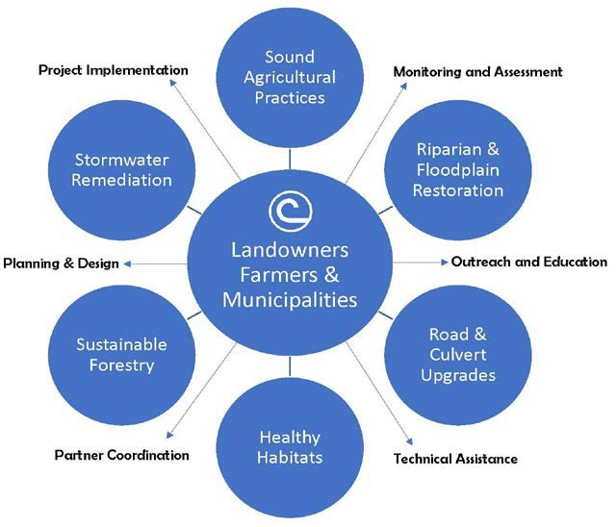

Based on the natural resources concerns within the Conservation District and the services provided by other organizational partners, each Conservation District may place a stronger emphasis on one or more program area(s). Projects and programs may also change from year to year depending on funding and priorities. The outcomes and benefits of Conservation District work serve several sectors, including agriculture, municipal stormwater, riparian and floodplain restoration, among others.
Examples of Conservation District activities and programs include agricultural assistance, tactical basin planning, municipal stormwater remediation, natural resource conservation and restoration.

Agricultural Assistance
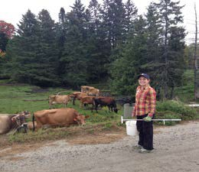
Conservation Districts educate and provide technical assistance to agricultural producers to help balance farming operations and healthy waterways. Districts assist farms in developing Conservation Plans and Nutrient Management Plans and accessing financial assistance programs to address soil and water quality concerns. This helps farms comply with Vermont’s Required Agricultural Practices (RAPs).
Many Conservation Districts also coordinate conservation practice implementation on farms including livestock exclusion projects, grassed waterways, stream buffers, reduced tillage and more.

Tactical Basin Planning
The Vermont Department of Environmental Conservation (DEC) develops Tactical Basin Plans for 15 major drainage basins in Vermont on a five-year cycle. These Basin Plans are part of the state’s Surface Water Management Strategy that is intended to identify and document clean water actions within each basin.
Conservation Districts are currently authorized through legislation to support and help execute Basin Plans as a partner and stakeholder. Conservation Districts provide outreach and technical assistance, seek public input, engage in data collection and monitoring activities, and assist DEC Basin Planners as needed to help inform and execute basin plans. Basin Plans are a key guidance document that can provide strategic guidance to Conservation District work plans and efforts to protect water quality.

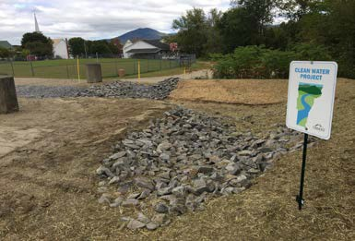
Municipal Stormwater Remediation
Conservation Districts assist municipalities to improve stormwater management by supporting the development of Stormwater Master Plans (SWMPs) and by providing outreach for Green Stormwater Infrastructure (GSI) and other stormwater remediation practices. SWMPs help identify opportunities for stormwater treatment and Conservation Districts assist communities to develop and implement specific projects to address these concerns.

Natural Resource Conservation and Restoration
Conservation Districts engage in a wide variety of natural resource projects and programs. Riparian and floodplain restoration is a key focus with stream buffer plantings coordinated statewide through the Trees for Streams woody buffer program. Districts also reach out to lake shoreline landowners to coordinate buffers and reduce erosion. In addition, Districts assist municipalities engaged in efforts to reduce road erosion and coordinate culvert upgrades to restore aquatic organism passage and improve flood resiliency.

Conservation District Structure and Governance

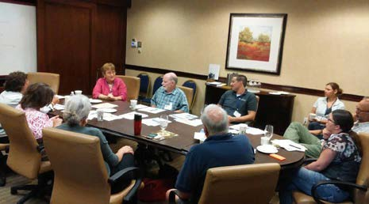
Board of Supervisors
Each Conservation District is governed by a Board of Supervisors that is made up of landowners who reside within the District. There are five elected or appointed supervisors per Conservation District, each serving five-year terms. By statute, a supervisor must meet the following minimum requirements: (10 V.S.A. §701 - 748)
  - Own land and reside within the boundaries of the district
  - Be, by training and/or experience, qualified to perform the services required of them
  - Not be an employee of the federal government

The Role of Supervisors
As a Board Supervisor, there are several aspects to governing a Conservation District, including but not limited to:
  - Developing and supporting the Conservation District’s mission
  - Guiding program priorities based on local natural resource needs
  - Working with Conservation District staff
  - Providing financial oversight

Developing Mission and Guiding Program Priorities
The Conservation District Board of Supervisors is a policy board, meaning that its primary focus is not on running the day-to-day activities of the Conservation District, but on informing and supporting the overall mission and long-term objectives of the District and ensuring that work is proceeding in the general direction approved by the board. The natural resources assessment, strategic plan, annual work plan and annual budget are key tools the Conservation District can use to organize its work.
Supervisors should be involved in plan development, particularly in determining the short- and long- term objectives of the District. While the board writes the plan and the staff carries it out, staff involvement is critical in plan development and supervisors often have a strong role in plan implementation. The Conservation District’s strategic plan, annual work plan, and annual budget should be approved by the Board of Supervisors and reviewed on a regular basis to determine if goals are being achieved.

When working on long-range and annual plans, supervisors should take a strong leadership role in the following areas:

  - Understanding the role of the Conservation District in addressing natural resource concerns in their community and ensuring that the Conservation District’s mission statement is aligned with this purpose.
  - Assisting with prioritizing resource problems and their relative importance to theConservation District’s mission. Supervisors should look at the big picture and develop broad policies that staff can work within to address individual concerns.
  - Supporting the development of objectives, strategies, and actions that address the planned outcomes within each natural resource concern.

Working with District Staff
Each District should adopt a Personnel Policy to be shared with District staff in an Employee Handbook. The District may make its own decisions regarding compensation, paid leave, benefits, and probationary periods, but all elements of the policy must be in accordance with federal and state employment laws. Examples of personnel policies, surveys and information about compensation and employee benefits are provided periodically by NRCC and VACD. The District Manager should be the board’s key contact for supervising the operation of the Conservation District. At least one board member should be available for consultation with the District Manager on a regular and frequent basis.

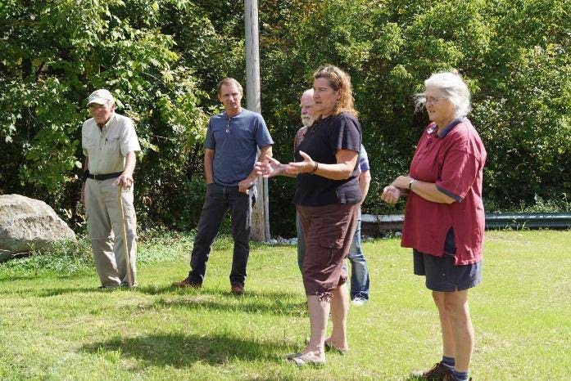
The board should work closely with the District Manager to:
  - Set work priorities
  - Develop and approve annual work plans budgets
  - Support staff training and professional development
  - Develop an employee evaluation system
  - Conduct the annual performance review of the District Manager (Normally the District Manager supervises and conducts annual performance reviews for additional staff.)
- Obtain liability insurance for District staff and supervisors, and bonding for those individuals entrusted with District funds and equipment

Providing Financial Oversight
The Board of Supervisors is legally responsible for ensuring that District financial operations are conducted in accordance with the Federal and State laws, follow Generally Accepted Accounting Practices (GAAP), and meet the requirements of funding agencies. Each Conservation District should have a Financial Policies and Procedures Policy that defines internal control systems and includes a procurement policy and conflict of interest policy. (The conflict of interest policy applies to District Board members as well as staff.) District Board members and staff should be insured against liability arising from financial errors and omissions (“bonded”). The Conservation District Manager and Bookkeeper are responsible for day-to-day financial operations. While the Treasurer is often the most financially knowledgeable person on the Board, the full Board needs to understand financial reports well enough to fulfill their oversight role. The Board reviews and approves the District’s annual budget as well as any documents that legally bind the District to fulfill financial obligations, such as grant agreements, contracts and Memorandums of Understanding. The Board also reviews monthly financial reports, including the check register, bank statements, profit and loss statements, balance sheets and budget to actual reports. Conservation Districts are required to submit year-end financial reports to the State Natural Resources Conservation Council. They are also required by statute to conduct audits or financial reviews, which may entail engaging a third party expert. Conservation Districts are also subject to external audits by state and federal funding partners, depending on the size and complexity of their budgets.

Board Officers and Operations
A variety of officer positions within the Board of Supervisors can facilitate effective operations. Supervisors may elect or appoint each other to officer positions at the District Annual Meeting or at a designated board meeting. These appointments should be reaffirmed annually or when a supervisor is re-elected or re-appointed.

Chair
The Board Chair has the primary leadership role for the Conservation District. The Chair is responsible for facilitating board meetings, and the Chair or Chair’s designee must be available for regular consultation with the District Manager between board meetings. This is an important way to facilitate communication and strengthen District leadership, and provides an opportunity for the chair and manager to jointly set board meeting agendas. The Chair also has signatory authority for the Conservation District, which can apply to contracts, grant agreements, and banking authorizations.

Vice Chair
The Vice-Chair assumes the role of Chair when the elected Chair is absent, and may provide additional support to the Chair as needed.

Treasurer
The Treasurer oversees the financial activities of the District. The Treasurer reviews and understands all financial reports presented to the board and ensures that the board and key staff understand the finances of the District. The Treasurer may assist the District Manager with the preparation of the District’s annual budget and other financial activities.

Secretary
The Secretary takes custody of the District’s board meeting minutes and other records and is responsible for the District’s adherence to Vermont’s Open Meeting Law. Specific tasks, such as preparing meeting minutes, may be delegated to a staff person for execution, but remain the responsibility of the Secretary.

Supervisor Recruitment
Perhaps the most important value of Conservation Districts is their connection to local landowners. Supervisors’ knowledge of the local land base and engagement in the community are vital for this essential connection. Successful supervisors have a strong social or professional network in the community, intimate knowledge of the working landscape, experience implementing conservation measures, and a variety of other skills needed to oversee the District. Each Conservation District Board of Supervisors should identify the knowledge and skills they are looking for in each recruitment based on their priorities and strategic plan, the knowledge and skills of current board members, and gaps the board has identified.

Conservation District boards benefit from a diversity of expertise. Farmers, land users and other members of the land-use economy have key experience that benefit Conservation Districts.
Experience in environmental conservation or natural resource sciences is also useful, as is experience in technical assistance to land users. Academic experience can bring a different contextual knowledge about natural resources. Experience in personnel management, contracting, fundraising and finance are important in contributing knowledge of governance structures, accountability, and strategic partnerships for the District. Boards should also consider a diversity of gender, age, race, etc. when filling vacant seats to ensure balanced representation of the local community.

Once the ideal skills and qualities are identified, District supervisors and staff can brainstorm about potential candidates among themselves and with local state and federal agency staff, non-profit staff, local government colleagues, college professors and other knowledgeable resource people, then reach out to potential candidates individually. Districts must also announce the opening through a public notice as described below, and may further publicize it with an article in their local paper, local listservs, website, radio, etc.

Supervisor Elections and Appointments
Vermont Conservation District supervisors are elected for five-year terms in public elections that are held once a year. There is no legal limit to the number of terms a supervisor can serve. NRCC maintains a supervisor directory indicating terms for each supervisor. Conservation Districts may check the directory to determine which supervisor’s term is expiring prior to starting electionprocedures.

Since Conservation District elections do not fall under the Vermont state statute for general elections, NRCC provides independent elections guidance and procedures to Conservation Districts. Each fall, Conservation Districts receive communications from NRCC with general guidelines, a suggested timeline, reminders about legal requirements, and sample notices and forms for annual elections.

As part of the annual supervisor recruitment and election process, Conservation Districts must post a legal notice in the local newspaper and in a second location (website or public bulletin, for example.) The legal notice states that petitions are available to all landowners within the boundaries of the Conservation District for the position of Supervisor. An interested candidate may secure a place on the ballot by obtaining at least twenty-five signatures on the petition provided. All signers must own land lying within the boundaries of the District and may sign more than one petition to nominate more than one candidate for supervisor. The deadline for submitting petitions is specified in the legal notice.

If only one petition is submitted, the petitioner shall be installed as Board Supervisor without an election. If no petitions are submitted, the Board of Supervisors may appoint a willing and qualified individual for the subsequent five-year term. If two or more petitions are submitted, the Conservation District must hold an election.

Conservation Districts are granted latitude to create their own supervisor election process as long as it is compatible with NRCC procedures and compliant with Vermont statute. As a result, there are variations among Conservation Districts related to the time, place and manner of their elections. For example, some Districts may hold elections in conjunction with their annual meeting, while others may create a four-hour polling time slot on the election date suggested by NRCC. Conservation Districts may also choose their own election date that deviates from the timeline suggested by NRCC.

Conservation Districts must conduct their elections with fairness and adequate publication of all election-related information to the voting public.

Supervisor Vacancies and Removal. In case of a board seat vacancy, remaining supervisors may appoint a supervisor for the remainder of the unexpired term at any time outside of the annual election procedures. Districts may choose to pass a bylaw permitting de facto resignations when a supervisor ceases to attend meetings or otherwise communicate adequately. Any supervisor may be removed by the NRCC, upon notice and hearing, for neglect of duty or malfeasance in office, but for no other reason (10 V.S.A. §701 - 748).

Supervisor Reimbursements. Conservation District supervisors are eligible for certain reimbursements related to their service, including mileage reimbursement at the federal rate and per diem at the state rate. Many District boards have discontinued per diems and mileage reimbursement in an effort to focus resources on program implementation, but this is the decision of each board. Associate supervisors and other volunteers are not typically eligible for reimbursements.

Associate Supervisors
Boards are encouraged to recruit associate supervisors to support the work of the District. While only officially elected or appointed supervisors may vote or hold office, non-voting advisory or associate supervisors can perform other functions of supervisors and assist the District with special projects.
This is an important way to expand the district’s social network, pool of expertise, number of helping hands, and build organizational capacity and long-term sustainability. Associate members may be appointed by the board at any time. Associate membership is also a good way to explore becoming an elected or appointed supervisor.

Orientation of New Supervisors
It is recommended that orientation for new supervisors include:
- Completion of an Oath of Office
- Review of Guidance Handbook to understand the purpose of Districts, the roles of supervisors and staff, and the Conservation Districts’ organizational infrastructure at the local, state and national level
- The Natural Resources Assessment of the Conservation District, relevant DEC Tactical Basin Plans, and/or Total Daily Maximum Loads (TMDLs) as applicable
- The District’s Strategic Plan, previous years’ Annual Reports, Annual Work Plan and Budget
- Other policy documents of the District (e.g. Personnel Policy, Financial Procedures)

State Structure, Governance and District Support

State Natural Resources Conservation Council
The State Natural Resources Conservation Council (NRCC), often called “Council,” is the state agency through which Vermont’s 14 Natural Resources Conservation Districts originally came into being.
NRCC’s mission is to advance conservation and water quality efforts in Vermont by providing strategic guidance, oversight, and operational support to Conservation Districts, to contribute a local perspective on conservation policies, and to facilitate the sharing of information among members and partners. NRCC provides a forum for Conservation Districts to interface with state and federal partners, secures and allocates funding to Conservation Districts, and may employ administrative or program staff who report to the board.

According to State Statute under 10 V.S.A. §701 - 748, the duties of the NRCC are to:
- Offer appropriate assistance to the supervisors and directors of Conservation Districts and Supervisory Unions

- Keep the Supervisors and staff of each Conservation District and Supervisory Union informed of the activities and experiences of all Conservation Districts and Supervisory Unions and facilitate an interchange of advice and experience between Conservation Districts and Supervisory Unions

- Coordinate the programs of the Conservation Districts and Supervisory Unions so far as this may be done by advice and consultation

- Secure the cooperation and assistance of the United States and any of its agencies and of agencies of the [State of Vermont] in the work of Conservation Districts and Supervisory Unions

- Disseminate information throughout the state concerning the activities and programs of the Conservation Districts and Supervisory Unions

- Act upon petition by any two or more Conservation Districts lying within the limits of the territory proposed to be organized into a union asking that a Supervisory Union be organized to f unction in the territory described in the petition

- Supervise and oversee annual elections of District Supervisors

Six representatives from Conservation Districts serve on NRCC, organized by regions of neighboring Conservation Districts referred to as Supervisory Unions.
Supervisory Unions to NRCC
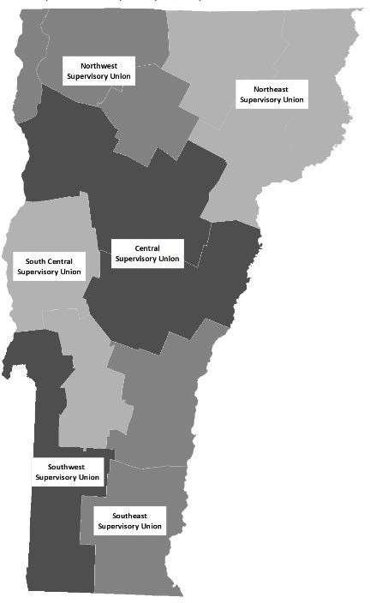
Supervisory Unions in Vermont are made up of the following
Conservation Districts:

Northwest Supervisory Union
Franklin, Lamoille and Grand Isle County Conservation Districts

Northeast Supervisory Union
Orleans, Caledonia and Essex County Conservation Districts

Central Supervisory Union
Winooski and White River Conservation Districts

South Central Supervisory Union
Rutland and Otter Creek Conservation Districts

Southwest Supervisory Union
Bennington County and Poultney Mettowee Conservation Districts

Southeast Supervisory Union
Windham County and Ottauquechee Conservation Districts

Each Supervisory Union appoints a supervisor from one of the Conservation Districts within the Supervisory Union as their representative to serve on NRCC. Supervisory Union representatives serve for terms of two years and may be reappointed. The representative's role on NRCC is to interface with and provide feedback to state and federal representatives attending NRCC meetings, help execute the business of NRCC, and share the policies and activities of NRCC back to the Conservation Districts within their Union. It is recommended that Conservation District supervisors and staff of each Supervisory Union meet locally at least once a year to share information and experiences, confirm priorities, and discuss the terms of their representative's service on NRCC.

There are three additional voting members of NRCC. They include the Secretary of the Agency of Natural Resources or their designee, the Secretary of the Agency of Agriculture, Food and Markets or their designee, and the Director of University of Vermont (UVM) Extension or their designee. This constitutes a total of nine (9) voting members of Council. There are associate or non-voting members of NRCC who provide support, assistance, information and recommendations, and participate in discussions. They include the USDA Natural Resources Conservation Service (NRCS) State Conservationist or their designee, and the Executive Director of the Vermont Association of Conservation Districts.

Vermont Association of Conservation Districts
The Vermont Association of Conservation Districts (VACD) is the membership association of Vermont’s fourteen Natural Resources Conservation Districts. It is a not-for-profit organization established in 1980. The mission of VACD is to promote the conservation of Vermont’s natural resources by representing and assisting the Conservation Districts and implementing statewide programs.
The VACD full Board of Directors is composed of fourteen members with one voting representative elected or appointed by each Conservation District. The full Board meets at least annually and more frequently as needed. The VACD Executive Committee is elected by the members at the annual meeting, and is composed of the President, Vice-President, Treasurer, and Secretary. The immediate past President may also participate in the Executive Committee. The Executive Committee supervises and supports the VACD Executive Director and oversees the work of the organization through frequent communications and periodic meetings.

VACD member services include:
- Facilitating information-sharing, dialogue and partnership development amongConservation Districts and between Districts and partner agencies at the local, state and nationallevels;
- Providing training and capacity-building support for Conservation District staff and board members;
- Communicating and representing Conservation District accomplishments and priorities tothe Vermont public and state and national policy-makers
- Securing funding for Conservation District programs.

VACD also implements statewide programs that serve Conservation District goals and constituents, including NRCS-supported Farm Bill technical assistance and Nutrient Management Plan programs and the Vermont Rural Fire Protection program. VACD is also the fiscal agent for the Vermont Envirothon.

A similar organizational structure to support Conservation Districts exists in most US states, with both a state agency in an oversight role, and a state association in an information-sharing and representational role. In Vermont, both NRCC and VACD provide information-sharing, representation, capacity-building and financial support to Conservation Districts. In some states, there is also a formal Conservation District Employees Association. Vermont Conservation District staff do not have a formal employee association, but hold frequent staff meetings for training, collaboration, information-sharing and mutual support. The VACD technical staff has an informal employee association that represents staff concerns to management.

National Structure, Governance and District Support USDA Natural Resources Conservation Service
The Natural Resources Conservation Service (NRCS) is an agency of the US Department of Agriculture and the largest funder and supporter of voluntary conservation carried out by private landowners in the United States. Conservation Districts have enjoyed a unique partnership with NRCS since our creation during the Dust Bowl era. When the federal agency that became NRCS was created, it soon become apparent that it

needed a direct link to private landowners at the local level to promote the implementation of soil conservation practices. Conservation Districts were created to provide that link.

NRCS programs are funded by Congress through the five-year Farm Bill and the annual agriculture appropriations (budget) bill. NRCS programs seek to protect and improve soil health, water quality and wildlife habitat through technical assistance and financial assistance to private landowners for conservation practice implementation that addresses natural resource concerns. In 2018, NRCS provided $6.3 million dollars of technical assistance and nearly $19 million in financial assistance to Vermont farmers and landowners, protecting and improving nearly 140,000 acres. NRCS also protects agricultural land and restores critical wetlands with permanent conservation easements, including 4,000 acres of conservation easements in 2018.

Conservation District and VACD staff provide education, outreach and technical assistance to agricultural producers to help nurture and facilitate their participation in NRCS programs. Our mutually beneficial partnership enables NRCS to provide work space and computer facilities to Conservation Districts in USDA service centers free of charge in exchange for District-led outreach activities that result in increased NRCS program participation. Co-housing with NRCS not only saves on office, computer and transportation costs; it also enhances the effectiveness of this important partnership. Conservation District staff attend local NRCS staff meetings to maintain open communication, and NRCS staff regularly attend and provide updates at District board meetings.

NRCS has Cooperative Working Agreements and Memorandums of Agreement with co-housed Conservation Districts that detail the nature of their cooperation to achieve common objectives. These agreements identify which NRCS resources the District may use and for what purposes, and what form of services or remuneration the District will provide to NRCS in exchange. If utilizing NRCS software and data, Conservation Districts are required to sign a “1619 Agreement” that protects the privacy and confidentiality of landowner data.

Local Work Groups
As key local partners of NRCS, Conservation Districts have a unique opportunity to provide input into NRCS program priorities to ensure that they address local concerns. This is accomplished through the Local Work Group, convened annually by the District. The Local Work Group is a meeting (or series of meetings) of local landowners and technical experts to identify and articulate natural resources concerns and priorities in the District. These priorities are then synthesized and integrated into the NRCS project selection process for that region.

National Conservation Partnership
Conservation Districts are supported by four national associations at the national level, some of which share staff. The National Association of Conservation Districts (NACD), the National Association of State Conservation Agencies (NASCA), the National Conservation District Employees Association
(NCDEA), the National Association of Resource Conservation and Development Councils (NARC&DC), along with NRCS, comprise the National Conservation Partnership which works to promote the implementation of voluntary conservation programs by landowners and community members on private and public lands.

National Association of Conservation Districts (NACD)

The National Association of Conservation Districts is the membership association of the nearly 3,000 Conservation Districts throughout the United States. NACD is an advocacy organization composed of voting representatives from each US state and territory who are elected or nominated by their respective state association.
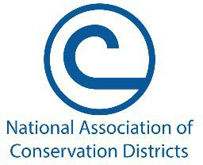

NACD’s mission is to promote the wise and
responsible use of natural resources for all lands by representing locally-led conservation districts and their associations through grassroots advocacy, education and partnerships. NACD organizes membership meetings throughout the year which focus on information-sharing, technical training, capacity-building and policy development.

NACD represents the voice of Conservation Districts in the US Congress and in dialogue with federal agencies. NACD has a ground-up policy development process that culminates in the approval of policy positions at its annual meeting, with a view to promoting policies that support the efforts of private agricultural producers and forest landowners committed to natural resource conservation. In recent years NACD has also been providing grants to Conservation Districts through the US, including for urban conservation and conservation planning.

Due to the historic partnership between NRCS and Conservation Districts, NACD has a close working relationship with NRCS. NRCS staff participate in most NACD meetings, providing updates on policies and programs, delivering technical trainings, and learning from the landowners and community members that Conservation Districts represent.

The National Conservation Foundation is NACD’s non-profit wing which manages the international Envirothon education competition and fundraises for Conservation District leadership programs.

National Association of State Conservation Agencies (NASCA)
NASCA is the national association that serves state conservation agencies. NASCA’s vision is to enhance the ability of its member conservation agencies to fulfill their agriculture and natural resource missions. Its mission is to strengthening members’ capacity and influence national programs and policies by providing leadership, focus and direction. Among other services, NASCA is the repository of a wealth of materials for training Conservation District supervisors.

National Conservation District Employees Association (NCDEA)
NCDEA is the association that represents and supports Conservation District employees. Its mission is to strengthen Conservation District employee professional capacity and influence national conservation policy by providing leadership and proficiency.

National Association of Resource Conservation and Development Councils
The NARC&DC assists Resource Conservation and Development (RC&D) Councils in developing partnerships that enhance the quality of life in America's communities. RC&D Councils serve to bring together the economic development and conservation programs of the US Department of Agriculture and other federal agencies. The NARC&DC acts as a liaison between Councils, foundations and the US government in legislative and intergovernmental activities. Unfortunately, due to a cut in Federal funds in 2014, Vermont’s two RC&D Councils closed their doors.

National Conservation Planning Partnership
In 2015, these four associations and NRCS revamped their partnership to focus on professionalizing conservation planning. The National Conservation Planning Partnership (NCPP) aims to better serve agricultural producers and forest landowners by reinvigorating conservation planning, improving the partnership’s capacity to deliver conservation planning assistance, ensuring the delivery of technically sound science-based assistance, and building a workforce of skilled conservation planners.

Partners
In addition to NRCS, there are many essential and enduring partners of Vermont Conservation Districts at the national, state and local levels that provide critical support and collaborative opportunities. Some of them are highlighted here.

Vermont Agency of Agriculture Food and Markets (VAAFM)

Vermont Agency of Natural Resources (ANR)
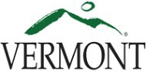

University of Vermont Extension

Farm Services Agency (FSA)
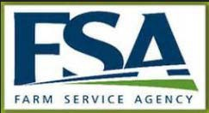

U.S. Fish and Wildlife Service (USFWS or FWS)

U.S. Forest Service (USFS)
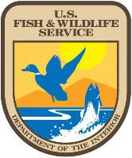

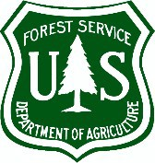

Lake Champlain Sea Grant

Watersheds United Vermont (WUV)
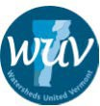

Lake Champlain Basin Program (LCBP)
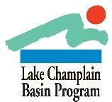

Vermont Land Trust (VLT)

Regional Planning Commissions (RPCs)

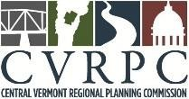

Town Conservation Commissions
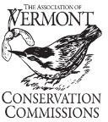

Farmers’ Alliances, Watershed Associations, Lake Associations, Anglers Associations, Towns and Schools

Acronyms

ACEP | Agricultural Conservation Easement Program
AFO | Animal Feeding Operation
ALE | Agricultural Land Easement
AMP | Acceptable Management Practices (forestry)
ANR | Vermont Agency of Natural Resources
AOP | Aquatic Organism Passage
BMP | Best Management Practice
CISMA | Cooperative Invasive Species Management Area
CLF | Conservation Law Foundation
CNMP | Comprehensive Nutrient Management Plan
CPA | Conservation Program Application
CREP | Conservation Reserve Enhancement Program
CSFO | Certified Small Farm Operation
CTA | Conservation Technical Assistance
CWF | Clean Water Fund
CWIP | Vermont Clean Water Initiative Program
DEC | Vermont Department of Environmental Conservation
DM | District Manager (of a Conservation District)
DO | Dissolved Oxygen
E&O | Education and Outreach
EPA | Environmental Protection Agency
EQIP | Environmental Quality Incentives Program – NRCS
FA | Financial Assistance
FAP | Farm Agronomic Practices - VAAFM program
FPR | Vermont Department of Forest Parks and Recreation
FSA | Farm Service Agency
FWP | Farmable Wetlands Program
GIS | Geographic Information Systems
GSI | Green Stormwater Infrastructure
HEL | Highly Erodible Land
LFO | Large Farm Operation
LTP | Land Treatment Plan (component of a Nutrient Management Plan)

MFO | Medium Farm Operation  Municipal Separate Storm Sewer System National Association of Conservation Districts Nutrient Management Plan  Natural Resources Conservation Council Natural Resources Conservation District Natural Resources Conservation Service Operations and Maintenance  Portable Skidder Bridge Required Agricultural Practices Road Erosion Inventory  Regional Conservation Partnership Program Request for Proposals  Regional Planning Commission  Revised Universal Soil Loss Equation, Version 2 Small Farm Operation  Stormwater Master Plan  Source Water Protection Program Tolerable Soil Loss (determined by RUSLE2) Technical Assistance  Tactical Basin Plan  Total Maximum Daily Load  United States Fish and Wildlife Service  Vermont Agency of Agriculture Food and Markets Vermont Association of Conservation Districts  Vermont Association of Planning and Development Agencies (Regional Planning Commissions) Vermont Environmental Stewardship Program  Vermont Housing and Conservation Board Vermont League of Cities and Towns Vermont Land Trust  Vermont Agency of Transportation  Vermont River Conservancy Wetland Reserve Easement
MS4
NACD
NMP
NRCC
NRCD
NRCS
O&M
PSB
RAPs
REI
RCPP
RFP
RPC
RUSLE2
SFO
SWMP
SWPP
“T”
TA
TBP
TMDL
USFWS
VAAFM
VACD
VAPDA
VESP
VHCB
VLCT
VLT
VTrans
VRC
WRE

For more information visit
www.vacd.org

